**IDEATION PHASE**

**BRAINSTORM & IDEA PRIORITIZATION**

|  |  |
| --- | --- |
| Date | 3 october 2022 |
| Team ID | PNT2022TMID15778 |
| Project Name | IoT based smart crop protection system for agriculture |

**Step:1**

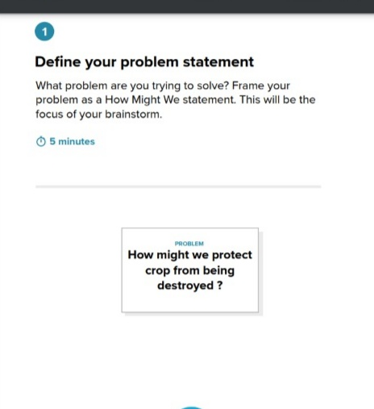

**Step: 2 Brainstorm, Idea Listing & Grouping:**

**BRAINSTORM:**

Jaya Swetha Kaviya Sri

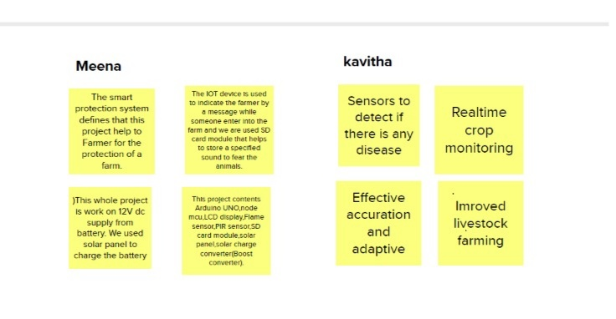

 Lakshmipriya Madhubala

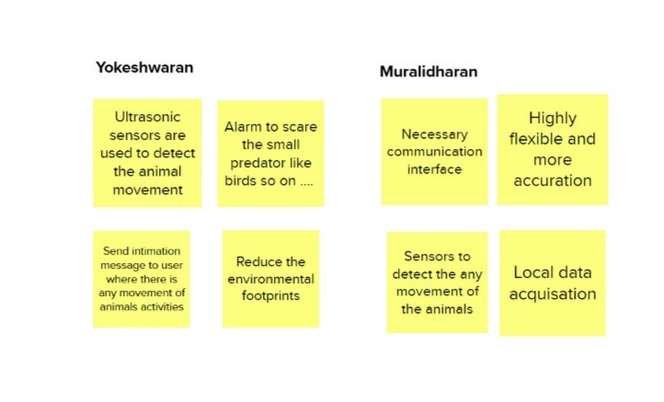

**GROUP IDEAS:** 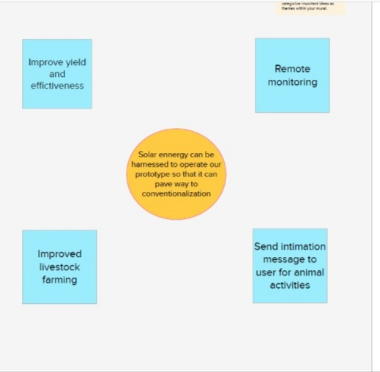

**Step:3**

**IDEA PRIORITIZATION:**

